Below all the URLs and special procedures, you need to implement/do for boosting your social media with Social-gator

#1 Twitter

You will need to create an APP on twitter, according to tutorials, below the content you need to submit to twitter developers to get the AP approval

(Step 1 from 5)
When Applying for Twitter APP Developer for the First Time
(This process will be as fast as only 2 days long in total)

============================================================
You need to paste this detailed information below in the required box
============================================================

I will Offer quality content based in online courses and online marketing services to people who are starting to market and promote online and is interested in this kind of topics.

All of them, will receive useful and quality information in tweets, they will have the opportunity of accessing to valuable information in order to cover their needs.

We will offer important news on tweets regarding our products and services so that way they will keep attentive to our tweets and upcoming offers, news, and broadcasts.

No user’s personal data will be stored, we will only access public information on user’s Twitter account
In Tweets we will search for specific keywords related to our proposal to find out a relevant audience, so that way we will market the specific niche being relevant.

Based on our user’s needs, we will create specific targeted tweets that really points to fully cover their needs in all the aspects, so that way they will be completely sure, the information included in our tweets is 100% relevant and interesting which leads the goal of improving client’s experience.

Tweets and content will be displayed online
Automated tweets will be published that will broadcast external RSS information with authorization from the owner

Automated Tweets for informational purposes, quality content and news related to our market niche will be published so that way we will focus only on being relevant and share relevant content to our users/followers of potential followers .

Automatic Direct messages will be sent only by explicit authorization of the user, they will need to have that notification feature enabled in their twitter account, also, we will only send one (1) direct message as “welcome message” and those welcome messages need to be 100% related to give thanks to that user for following back and invite them to visit (completely voluntary) our corporate website to find out more important and qualified content they want to have or get access.

We will NEVER EVER do spamming, nor send out duplicate or forbitten content

(Step 2 from 5)
When Twitter Requires more Information
(this comes to your inbox once you applied)

This is what twitter sends you when you Apply for the first time and you are not approved yet
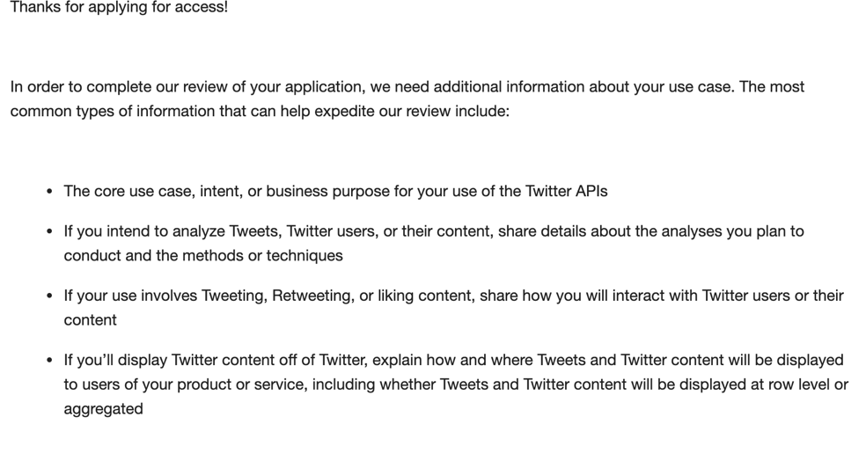

==============================================
And this is what We will recommend you to answer
(be sure to give this answer at least 4 to 6 hours after receiving the notification)
==============================================
Hello there, I will try to do my best on explaining in detail the additional information you are requesting the following way:

The application will not be used for commercial use. It will be used to share information of interest to Twitter users and interact with them.
Also, I pretend to create a community that gets a good experience and interacts by sharing content - I will Offer quality content based in online courses and online marketing services to people who are starting to market and promote online and is interested in this kind of topics -
If any user requires more information about my services either quality content in deep, more details on any topic or more resources to fully understand my content, it will only be done if the user contacts me voluntarily.
Only the description of the users will be analyzed to determine if their interests coincide with those of the users who follow me and with the information shared, My Intention is to fully focus on specific market niches that cover exactly my services and information that I share as “Online Marketing”, “internet Marketing”, “Social Media” or “how to promote your business online”, etc., those are some of the topics that I will lead to boost by using twitter in order to create a strong community interested on quality content.
I am fully committed on teaching people/users the good side of this social media digital revolution by creating a good environment completely out of spamming or fraudulent information.
Also, my Application will not be used to send spam or violate any rule of publication or tracking of Twitter
When a Twitter user follows me back, I will send him/her a welcome message that will tell him/her what kind of content will be found in my profile, tweets and the quality content that I will share.
Twitter Content will not be shown anywhere. It will only be displayed in Twitter.

I hope this can help you more in Deep, if you have additional questions, please let me know

Thanks in Advance
With Regards

(Step 3 from 5)
When Twitter Requires more Information for the Second time
(If this is not your case, please move to Step 4 )

Sometimes Twitter requests deeper explanation about the scope of work of using their API, in that case, they send you some kind of notification like this below:

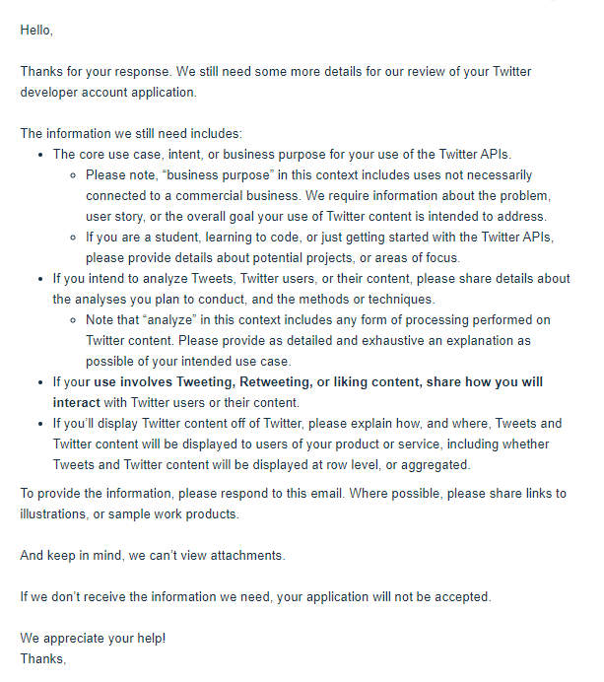
If that above is your case, we recommend you answer like this below:

Hi there, Thanks for replying, please read below:
I will focus on the first and last requirement which goes like this:
First:
The core use case, intent, or business purpose for your use of the Twitter APIs.
Last:
If your use involves Tweeting, Retweeting, or liking content, share how you will interact with Twitter users or their content
As I replied back before, my intention is not connected to a commercial business activity, but for sure will detail more in deep information about my core use case:

The Problem or the overall goal:
How to create a reliable and qualified twitter audience interested in my online activity, in order to :

1.- Make people aware of social media news environment
2.- Grow my twitter audience

My Online services are based on my personal skills on communicating the latest news about social media trending spaces that offer the opportunity to any user to be at the top of those latest news.

Based on that above, my market niche for “spreading” and “accomplishing” my overall goal is related to the Online Marketing world, for example:

I could start broadcasting (tweeting) to my audience the most relevant and important news about:

Google
Facebook
Twitter
YouTube
SEO

Among others, and, the main tool that I use to share those top news to my audiences is based on RSS feeds, and those RSS feeds are going to give me TONS of qualified and relevant information about not only to what I want to share to my audience, but what they want to hear from me, for example, below some few resources I got in order to accomplish my overall goal:

https://about.fb.com/news/
https://business.instagram.com/blog?
https://www.thinkwithgoogle.com/
https://webmasters.googleblog.com/
https://youtube.googleblog.com/
https://searchengineland.com/
https://marketingland.com/
https://www.socialmediatoday.com/
https://www.puromarketing.com/
https://www.marketingdirecto.com/
https://rockcontent.com/es/categoria/noticias-es/

Based on that above, in my research and development daily basis activities, I could also do a retweeting core use of the top twitter profiles that I consider, will be useful for my audiences to get access to, for example, below few cases of the qualified twitter users that I use to do a research of their content that fit in my audience’s needs:

https://twitter.com/randfish
https://twitter.com/Marketwired
https://twitter.com/ducttape
https://twitter.com/Kissmetrics
https://twitter.com/ThisIsSethsBlog
https://twitter.com/MarketingLand
https://twitter.com/SEngineLand

Among much more others.
Finally, I took my full time to analyze the content before tweeting it to my audience either they are in English or Spanish speaking audience.

Thanks in advance and Regards

(Step 4 from 5)
Finally, Twitter sends out the last notification like this:
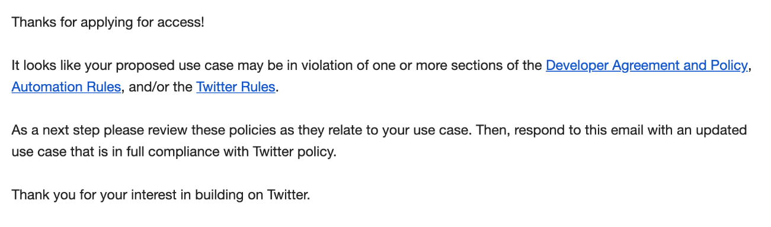

Which you will respond this way:
(be sure to give this answer at least 4 to 6 hours after receiving the notification)
Hello and thanks for reviewing my application,
I have carefully reviewed twitter’s Developer Agreement and Policy, Automation rules and Twitter Rules, finally I add and will be committed to do Add/Improve the following important use case below:
1.- My App fully Create Important solutions that automatically broadcast helpful information in Tweets (In fact that is one of the foundation of my online service by using social media)
2.- I will Run creative campaigns that auto-reply to users who engage with my content
And Of Course, I will Make sure my application provides a good user experience and performs well — all the time – because we have all the experience and resources to do it

My App will also fully respect all twitter rules as we I will only share quality content in order to engage my audience and fulfill their needs

Finally, my intention is to preserve the good environment with twitter community being 100% friendly and respectful According to not only twitter Developer Agreement and policy but by the nature of my online activity, by enhancing final user experience by using twitter as one of the most important communication media out there

please let me know if you need anything else
With regards,

(Step 5 from 5)
Finally, you’ve Got the Approval in your Inbox:

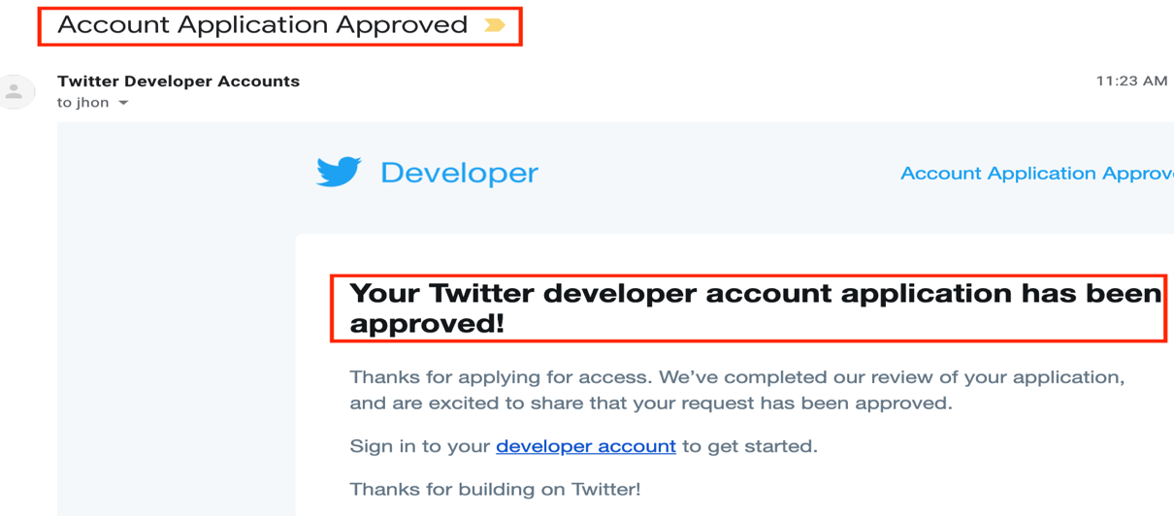

#2 Social Networks Developer’s URLs

Below all the Social Network’s URLs which you need to visit to create all your APPs

Twitter:
https://developer.twitter.com/en/apps
LinkedIn
https://www.linkedin.com/developers/apps

Youtube:
https://console.developers.google.com/apis/dashboard?hl=EN
-If you need to increase quota capacity when uploading YouTube videos, please go to:
https://console.developers.google.com/cloud-resource-manager?hl=en-419

Pinterest:
https://developers.pinterest.com/apps/

Vimeo:
https://developer.vimeo.com/apps/new?source=topnav

#3 Call Back/Redirect URLs

Call-backs/Redirect URLs

Twitter:
https://social-gator.com/api/socialaccounts/twitter/callback

Pinterest:
https://social-gator.com/api/socialaccounts/pinterest/callback

Youtube:
https://social-gator.com/api/socialaccounts/youtube/callback

LinkedIn:
https://social-gator.com/api/socialaccounts/linkedin/callback

Vimeo:
https://social-gator.com/api/socialaccounts/vimeo/callback

#4 Social-Gator Policy Privacy and T&C - URL

Privacy:
https://social-gator.com/privacyPolicy

